|  |  |  |  |  |  |
| --- | --- | --- | --- | --- | --- |
| **ID** | **:** | **PFI02-04** | **Company** | **:** | 유한양행 |
| **프로그램 명** | **:** | **자사몰 수금 반제취소 관리** | **Requested by** | **:** | **전승훈** |
|  |  |  | **Function Spec. by** | **:** | **한진웅** |
| **개발유형** | **:** | **Report** / **Online** / Script / **BDC** / Query  / User Exit / Modification / Interface / Fiori | **Technical Spec. by** | **:** |  |
| **수행주기** | **:** | Yearly / Monthly / Weekly / Daily / **Anytime** | **Date** | **:** | **2023-03-31** |
|  |  | Batch Job : Yes/ **No** | **Version** | **:** | v1.0 |

**[ Contents ]**

Revision History 2

Functional Specification Design 3

Basic Business Needs 3

Business Rules 3

Function Details 4

Technical Specification Design 6

Program Identification 6

Program Logic Details 6

## Revision History

| Date | Author | Version | Change Reference |
| --- | --- | --- | --- |
|  |  |  |  |
| 2023.03.31 | 한진웅 | 1.0 | Initial Created |
|  |  |  |  |
|  |  |  |  |
|  |  |  |  |

## Functional Specification Design

1. If you use a user-friendly name for this customization as the replacement for <Subject>, the following paragraphs will default nicely.

### Basic Business Needs

자사몰 수금 반제취소 관리

### Business Rules

#### Business Owner

#### Pre-requisites

N/A

#### Business Rule

1 예수금과 AR이 반제된 전표를 역분개 함.

### Function Details

#### Screen Layout – 자사몰 수금 반제취소 관리

1. 초기화면

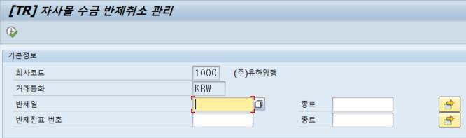

1. 출력화면

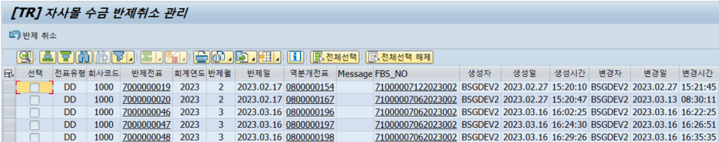

#### Special Logic

N/A

## Technical Specification Design

### Program Identification

#### Program Information

* Program Name

ZTRR0350N

* Transction Code

ZTRR0350N

### Program Logic Details

#### Screen Layout

1. 조회화면



1. 결과화면



#### Special Logic

1. 실행 옵션

: N/A

1. 버튼 처리

2-1. 반제 취소

   WHEN 'EXEC'. *" 반제취소*  
        PERFORM CANCEL_DATA.

1. 주요 CBO Table

3-1. ZTRT0080 : 수금유형 별 예수금계정 정보 추출

3-2. ZFBT0102 : 예수금 내역 추출

3-3. ZTRT0040, ZTRT0050 : 처리한 전표정보 추출

3-4. ZTRT0150N : 입금내역( MALL )

1. 주의 할 로직

N/A