|  |  |  |  |  |  |
| --- | --- | --- | --- | --- | --- |
| **ID** | **:** | **PFI02-03** | **Company** | **:** | 유한양행 |
| **프로그램 명** | **:** | **자사몰**  **수금관리(MALL)** | **Requested by** | **:** | **전승훈** |
|  |  |  | **Function Spec. by** | **:** | **한진웅** |
| **개발유형** | **:** | **Report** / **Online** / Script / **BDC** / Query  / User Exit / Modification / Interface / Fiori | **Technical Spec. by** | **:** |  |
| **수행주기** | **:** | Yearly / Monthly / Weekly / Daily / **Anytime** | **Date** | **:** | **2023-03-31** |
|  |  | Batch Job : Yes/ **No** | **Version** | **:** | v1.0 |

**[ Contents ]**

Revision History 2

Functional Specification Design 3

Basic Business Needs 3

Business Rules 3

Function Details 4

Technical Specification Design 6

Program Identification 6

Program Logic Details 6

## Revision History

| Date | Author | Version | Change Reference |
| --- | --- | --- | --- |
|  |  |  |  |
| 2023.03.31 | 한진웅 | 1.0 | Initial Created |
|  |  |  |  |
|  |  |  |  |
|  |  |  |  |

## Functional Specification Design

1. If you use a user-friendly name for this customization as the replacement for <Subject>, the following paragraphs will default nicely.

### Basic Business Needs

자사몰 수금관리(MALL)

### Business Rules

#### Business Owner

#### Pre-requisites

N/A

#### Business Rule

1 입금된 예수금 전표(FBS_NO)와 AR리스트 반제 기표 함.

### Function Details

#### Screen Layout – 카드수금관리(MALL)

1. 초기화면

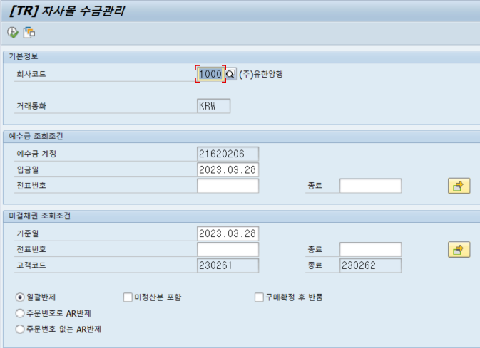

1. 출력화면

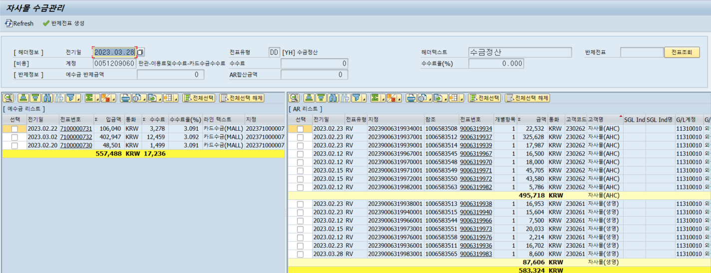

#### Special Logic – 카드수금관리(MALL)



## Technical Specification Design

### Program Identification

#### Program Information

* Program Name

ZTRR0340N

* Transction Code

ZTRR0340N

### Program Logic Details

#### Screen Layout

1. 조회화면
2. 일괄반제



1. 결과화면
2. 반제처리



#### Special Logic

1. 실행 옵션

: 정산구분 일괄반제(미정산분 포함, 구매확정 후 반품), 주문번호로 AR반제, 주문번호 없는 AR반제

1. 버튼 처리

2-1. 전표내역추출

   WHEN '&ENT'. *" 전표내역추출*  
        PERFORM GET_TEXT_DATA.

      PERFORM AM_ADDON.

2-2. 전표처리

   WHEN '&RST'. *" 전표처리*  
        PERFORM POST_DOCUMENT.

2-3. Refresh

   WHEN '&REF'. *" Refresh*  
        PERFORM REFRESH_DATA.

2-4. 전표조회

   WHEN '&REF'. *" 전표조회*  
        PERFORM DISPLAI_DOCUMENT.

2-5. 차/대변 금액 확인

   WHEN '&CHK'. *" 금액계산*  
        PERFORM CHECK_AMOUNT.

1. 주요 CBO Table

3-1. ZTRT0150N : 입금내역( MALL )

1. 주의 할 로직

N/A